Name : Sakthi Manoj R Reg No : 192324236
PROGRAM 15
Perform Exploratory Data Analysis on the Iris Dataset
Aim:
To perform exploratory data analysis on the iris dataset using dimensions, summary statistics, standard deviation, quantiles, and grouping by Species.
Procedure:
Step 1: Open RStudio or the R console on your computer.
Step 2: Load the built-in iris dataset.
Step 3: Use dim() to find the number of rows and columns in the dataset.
Step 4: Apply summary() to view basic statistical details for each variable.
Step 5: Use sapply() with sd to calculate the standard deviation of the numeric columns.
Step 6: Use quantile() to find the quantiles of the Sepal.Length column.
Step 7: Use aggregate() to calculate the mean of numeric variables grouped by Species.
Step 8: Display the results to observe the statistical characteristics of the dataset.
Output :
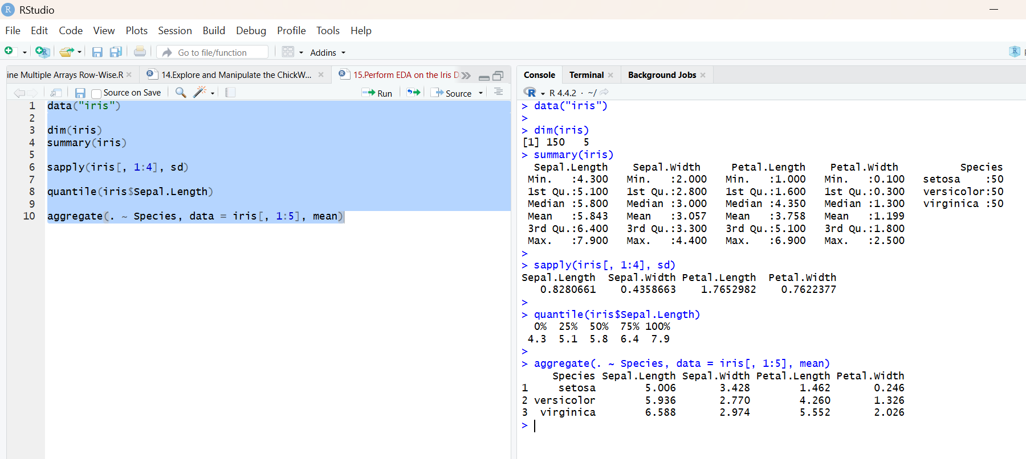
Result:
Hence the output is verified successfully.

